Shelburne Bridge
Coordinates: 44; 24’; 18.78” 71; 04’; 05.69”

Location: Shelburne, New Hampshire. From Gorham, NH, go east on Route 2 then take a left onto Meadow Road and go across the river. The launch site is on the left, down a short gravel road.

Owner: New Hampshire DOT right of way Manager: Town of Shelburne and Mahoosuc Land Trust

Launch facilities:
There is a rocky bank; canoes and kayaks are generally launched from the rocks under the bridge. Launching is difficult and into moderately fast current.

Miles to downstream access: 3
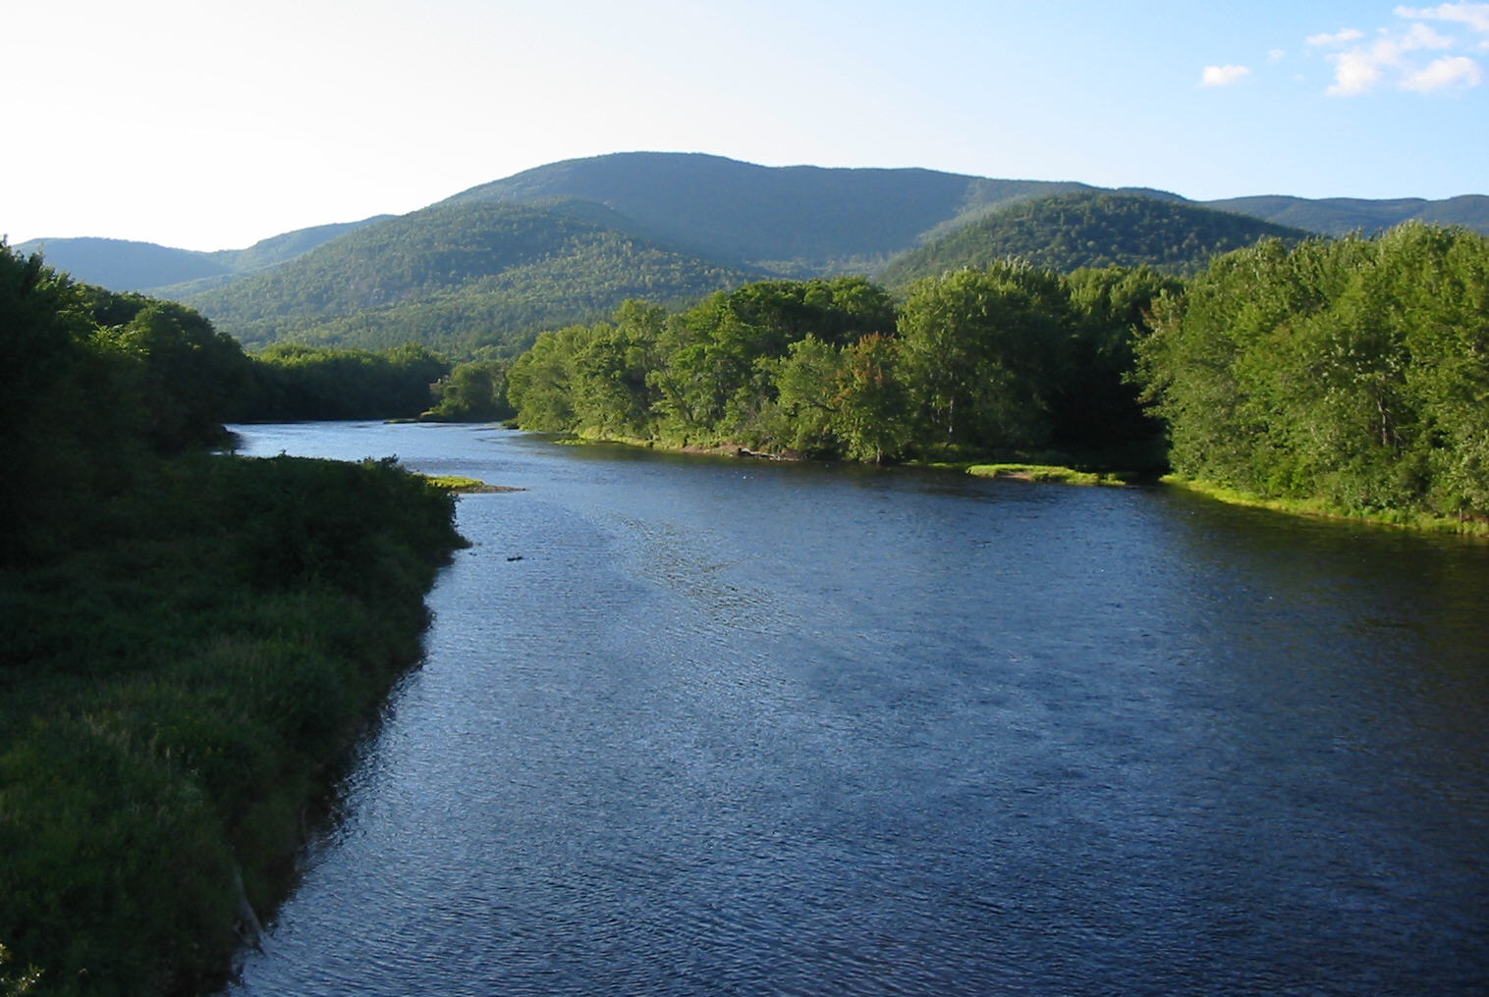
Parking:
There is limited parking for approximately 8 vehicles in a gravel lot. Drift boat access is possible but difficult.

Amenities:
None

Water Conditions:
Fast moving current with short sections of rips and Class I rapids at intervals downstream.

General comments:
Historic Shelburne Village is small but aesthetically enjoyable. Philbrook Farm Inn offers travelers an opportunity to stay at an historic property. Upstream, Gorham offers a variety of amenities, several motels, various eateries, shopping, and historic properties. Gorham is the northerly gateway to Mount Washington attractions such at the Cog Railway, and the White Mountain National Forest. Many private lands offer tremendous hiking opportunities.

Upstream access to Reflection Pond (above Lead Mine Dam at North Road in Shelburne) is now gated.

Androscoggin Canoe Trail
The Meadow Road access site is the most up-river point of the Androscoggin Canoe Trail that was developed by the Mahoosuc Land Trust. The Trail consists of eight sites with the most down-river site being above the falls in Rumford. The trail starts in the historic village of Shelburne, New Hampshire and passes the picturesque town of Bethel, Maine, home to Gould Academy and a beautiful National Historic District. The Moses Mason historic house and museum is located in the District. The trail ends just above downtown Rumford that also contains a National Historic District. The Strathglass Building is located in the District.

